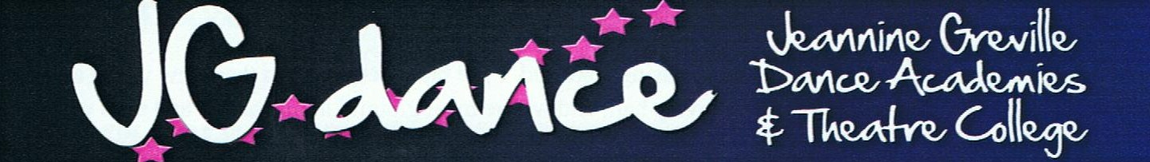

8th OCTOBER 2018

Caversham AUDITIONS

For pupils not doing a medal test this time

MAIN HALL

Class 2(pinks) 4.00 to 4.20pm TAP with Miss Kelly
Class 2(pinks) 4.20 to 4.40pm ACRO with Miss Kelly
Class 2(pink) 4.40 to 5.20pm STAGE with Miss Kelly
NO CLASSES FOR THE OLDER CLASSES ON AUDITION WEEK
Pupils are encouraged to watch the medal test auditions so they know what to expect when they come to do one.

